**Laboratory Work 2**

**More HTML elements**

**Tasks**

1. Create a new html file and name it as “Books.html”. List your 3 favorite books on the page using **HTML List** tags, where the type of bullet must be *square*.

The page should look like this:

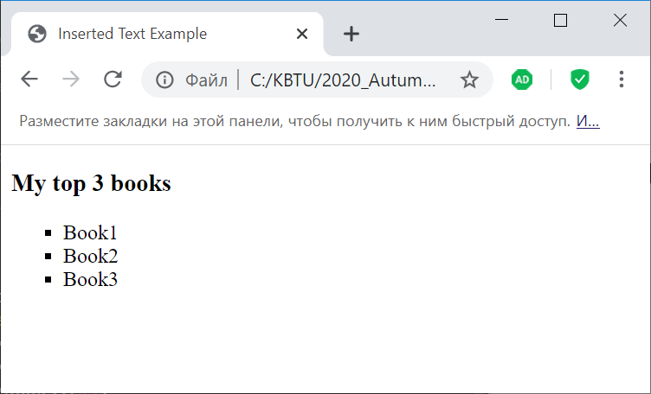

1. Create a new html file and name it as “Movies.html”. Display your top 3 films on the page using **HTML tables**.

The page should look like this:

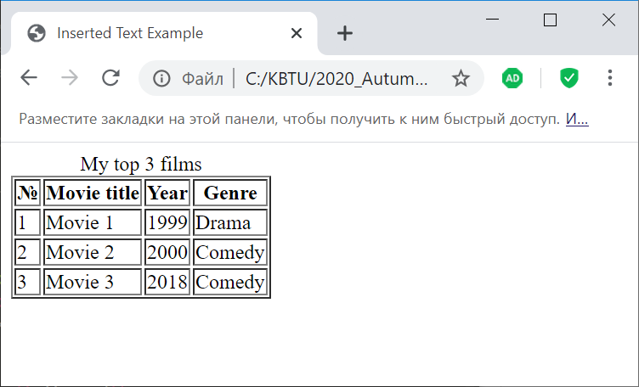

1. Create a new html file and name it as “Brands.html”. Show your favorite 3 brands on the page using **HTML tables.**

The page should look like this:

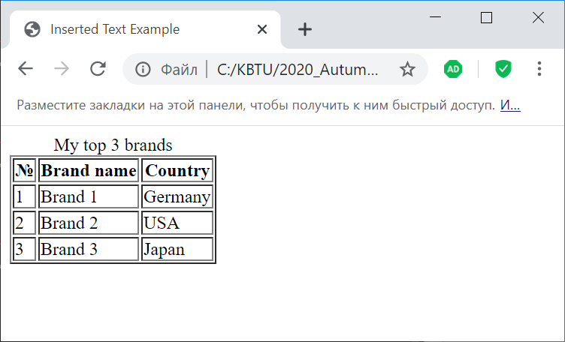

1. Mark the first brand on the last page (use text formatting tags).
2. Try to use in tables the *colspan* and *rowspan* attributes.

**Don’t upload this work, just be prepared to defend it.**